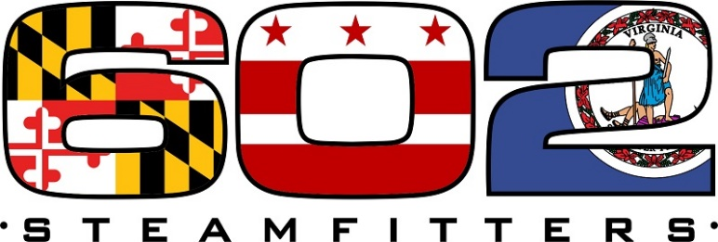
proudly presents it’s
2022 AWARDS DINNER
Saturday, May 14, 2022
6:30 p.m. till 12:00 a.m.
at
Martin’s Crosswinds
7400 Greenway Center Drive
Greenbelt, MD 20770
Come and celebrate our Awardees
$50.00 per ticket Non Refundable
For Ticket Information and Seating Call Sandra Savia
301-333-2356 ext 3 & 7

If you need a reservation at the Holiday Inn
please call
1-301-982-7000, and request a reservation with
“Steamfitters Local 602”
Book before April 30, 2022 to get a rate of $99.00

